Reservoir Characterization Integrating Seismic Attributes and Petrophysical Properties: Case Study from North Ustyurt Jurassic Reservoir
B. Durmagambetov, KNOC; Almaty, Kazakhstan; S. Yessalina, D. Kovyazin, A. Kuvanyshev, T. Bashimova, B. Kulbatyrova, M. Bektybayeva, and E. Deskubes, SLB, Astana, Kazakhstan

OBJECTIVE: Highly heterogeneous m ulti-stacked channel system of the Jurassic sequence has been modeled within one of the fields in the North Ustyurt Basin. The main objective of the work was to predict the distribution of different rock types in highly heterogeneous depositional setting, and to forecast undrained sweet spots to increase oil production.
METHODS PROCEDURES, PROCESS: The complex reservoirs assemblage has been characterized with the use of seismic, log and core data, and implemented rock typing methodology, based on machine learning technique (ML). 3D seismic data combined with well logs have been utilized for mapping fluvial reservoirs away from the well control, engaging co-rendering of seismic attributes (Envelope, RMS, Coherence), eXchroma and spectral decomposition. Interpreted geobodies were further utilized for rock typing based on classification with supervised training. The model was trained on core-derived estimates from routine and special core laboratory measurements of 7 wells to forecast log data. The outcomes were further applied to generate a 3D static model to predict facies.
RESULTS, OBSERVATIONS, CONCLUSIONS: Analysis of well data with 3D seismic in the studied area allowed to delineate extensive multi-stacked channel systems within the Jurassic sequence, The channelized systems identified on the log and core data appeared to be highly corelative with the results
of 3D seismic imaging. In total, twelve superimposed stacked channel systems of various morphologies ranging from relatively straight to meandering were mapped by co-rendering of seismic attributes. Extracted geobodies were further utilized as main guidance for rock-typing procedure based on ML technique.
Petrophysical rock types were estimated on core samples using Winland plot employing porosity vs. permeability and MICP-derived pore throat radius (PTR) cutoffs. The following three major PTR rock types were identified: <0.8 µm, 0.8-2.4 µm, > 2.4µm, corresponding to permeability ranges: <1 mD, 1-10 mD, > 10 mD, accordingly. This outcome was further utilized in training ML on core data to implement the forecast
on log data. Among various tested Dataiku classification algorithms Random Forest showed the highest confidence prediction on the confusion matrix and was selected for PTR rock typing. Implemented rock type classification showed general consistency with observed well performance and fluid behavior, enabling geologically consistent history-matching to get forecasts for future reservoir management activities,

2

NOVELTY: The main output of this work was delineation of rock typing of the reservoir rocks within the channel systems using ML technique. Our prediction model fits well with production data, demonstrating advantages of applied ML technique in classification and characterization of heterogeneous channelized systems. This Is important in terms of evaluation of the impact on dynamic behavior in the main oil-bearing reservoir parts of the case study.
Introduction
The study area is one of the oil and gas fields of the North Ustyurt Basin, which is located in the western Kazakhstan. The basin remains poorly explored with quite few hydrocarbon accumulations discovered, mostly distributed In the western part. The exploration campaign started since 1960s led to a few discoveries during late 1960s and in 1970s. Liquid and gaseous hydrocarbon accumulations have been discovered in the basin.
Natural gas fields occur at shallow depth in the northern part of the region within Eocene sandstones. Commercial oil fields are situated mainly in the western parts of the basin within the structural traps of the Jurassic section, at a depth exceeding 2500 m. The main reservoir rocks are Early to Middle Jurassic continental and upper Callovian-Oxfordian shallow marine clastic rocks. Continental Early to Middle Jurassic sedimentary rocks are highly heterogeneous, consists of alluvial and lacustrine deposits. The studied area, representing one of the most prolific oil and gas fields of the region contains hydrocarbons reservoired in the Early-Middle Jurassic part of the sequence. The sequence is characterized by development
of extensive fluvial system, comprising of multiple stacked sand beds laterally discontinuous and frequently intercalated by coal-bearing intervals. The study aimed to examine this setting based on drilling and seismic data highlighting the importance of an integrated geophysical and geological approach to achieve better reservoir characterization of fluvial systems with respect to prediction of the distribution of reservoir rock types based on machine learning models. Various seismic attributes, including enhanced high-resolution techniques such as Spectral Decomposition and eXchroma have been utilized to provide supporting evidence of the development of fluvial setting. Linking seismic-driven facies predictions with log- and core- derived estimates of reservoir properties enabled to define relationships and predict the spatial distribution
of reservoir properties in the 3D model.
Geological setting
The North Ustyurt Basin geographically covers territory of Kazakhstan and Uzbekistan, located between the Caspian Sea and the Aral Lake. It constitutes the northern part of the Ustyurt Plateau, covering an area
of about 250 000 km². The northwestern boundary of the basin terminates against the South Emba Paleozoic uplift, while boundary between the North Caspian Basin and the North Ustyurt is not well defined. In the south basin borders the Central Manyshlak and Central Ustyurt uplifts. In the east the North Ustyurt extends toward the Aral Lake. The basement is considered to be stratigraphically heterogeneous according to seismic and limited drilling data (Babadzhanov et al., 1986). It comprises Upper Precambrian massifs and deformed Caledonian foldbelts, possibly containing oceanic or transitional crust in the northern part dipping to the depth of 11km. The age of the basement rocks is unknown, possibly Early Proterozoic (Khain, 1977), Late Proterozoic (Milanovsky, 1987), and late Paleozoic Hercynian (Letavin, 1980). The basement rocks are
overlain by pre-Jurassic structurally deformed intermediate complex.
During Late Devonian-Early Permian time the studied region was evolving as a cratonic fragment, composed of platform-type carbonates and elastics, unconformably overlying older rocks. Later in prelate Visean and Early Permian the North Ustyurt block collided with the Russian craton along the South Emba suture and with Kazakhstan continent on the east. Collision along the southern suture zone took place during Early Permian. Tectonic evolution of the basin was affected by the Central Mangyshlak rift system

3

developed during Late Permian. The major impact was due to inversion of the rift system in the latest Triassic
or earliest Jurassic, which caused thrusting in southern areas of the North Ustyurt. With the beginning of Jurassic, the North Ustyurt entered the platform stage of the evolution with accumulation of 5 km sediments. Only slight tectonic movements affected the basin during that time,
The sedimentary rocks in the North Ustyurt are predominantly siliciclastic with several hundred meters to 5 km in thickness. The sedimentary succession can be generally subdivided into Permian-Triassic, Jurassic- Cretaceous and Paleogenic sections according to lithological composition and depositional conditions. The Permian-Triassic section is composed of red beds, while Lower-Middle Jurassic is infilled by 500-1000 m thick continental, coal-bearing, clastic sediments. The Upper Jurassic rocks are 100–300 m thick, consist of Upper Jurassic Kimmeridgian-Tithonian carbonates and Callovian-Oxfordian marine shales. The thickness
of carbonates ranges from 50 to 100 m. Cretaceous rocks are mainly marine clastic with thickness in the range of 1000-2600 m. The Tertiary sequence includes thick Paleocene–Lower Miocene and thin Middle Miocene-Pliocene siliciclastic rocks admixed with carbonates and marls.
Description of generalized lithostratigraphy of the North Ustyurt Basin is given in Daukeyev et al (2001) (Fig. 1).

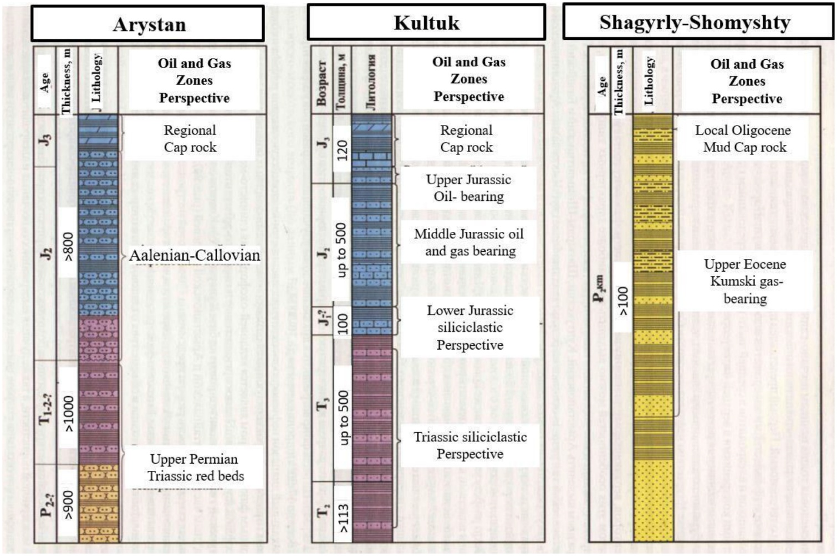

Figure 1—Generalized lithostratigraphy of the North Ustyurt (Daukeyev et al., 2002).
Methodology
For building 3D reservoir model all existing geological, geophysical, and field data were collected for analyses and interpretation. The database includes 130 wells with log, core and cuttings data and 3D post- stack seismic cube (177,1 km²), including vertical seismic profile (VSP) data available for one well. Initially acquired in 2006, 3D seismic data were reprocessed in 2012.

4

At first stage, a structural framework of the modeled area was created involving lithostratigraphic well correlation, horizon and fault interpretation based on seismic data, The key horizons at first picked on the well log data, were further identified on seismic and traced over the entire study area, Seismic well tie analyses required generation of synthetic seismograms (SWT) to match the time of the target horizons within the seismic time section. Synthetic seismograms were generated with the use of VSR sonic, and density logs to match the well tops with corresponding seismic reflectors, along with lithological descriptions from core and cuttings data. A layer-cake velocity modeling approach was applied in the domain conversion
of interpreted horizons and faults. In the next step the sequence was subdivided into smaller units based
on sequence stratigraphie approach to facilitate the interpretation and mapping of fluvial systems. These detailed well markers were integrated into the modeled structural grid to subdivide the main zones into subzones.
Interpretation of depositional facies was accomplished with the use of well data with core and cuttings at well locations with review of regional literature, followed by seismic facies analyses. Interpretation
of electrofacies with sedimentological analyses provided key control for interpretation of depositional environments and vertical and lateral facies variations. Prior to these analyses detailed well correlation was accomplished to clarify structural and stratigraphie framework of the reservoir, based on interpretation of key horizons and fault systems. The key horizons picked on the well log data were further traced on seismic
over the entire study area. In the next step the sequence was subdivided into smaller units based on sequence stratigraphie approach to facilitate interpretation and mapping of fluvial systems.
Fluvial facies interpreted on well data were mapped away from the well control based on 3D seismic data, engaging co-rendering of seismic attributes (Envelope, RMS, Coherence), eXchroma, using time slices and horizon probes and spectral decomposition with different wavelet and RGB blending of the frequency cubes. Interpreted geobodies were further utilized for rock typing based on classification with supervised training, The model was trained on core-derived estimates from routine (RCA) and special (SCAL) laboratory measurements to forecast on log data, Petrophysical evaluation involved results of RCA available in 30 wells and SCAL available in 7 wells with measurements of capillary pressure, mercury injection capillary pressure (MICP), and centrifuge-derived relative permeability and residual water saturation. Interpretation
of porosity was accomplished with the use of neutron, density and acoustic logs, validated against RCA and CMR (5 wells) data. Volume of shale (Vsh) was estimated from gamma ray (GR) logs with application
of Old-Larionov empirical model. For water saturation (Sw) evaluation Archie’s equation and the double water equation were utilized.
The outcomes were further applied to generate a 3D static model to predict lithofacies and petrophysical properties away from well control. Th channel part and flood plain background were modeled separately to prevent mixing of input statistics (fractions, variograms, anisotropy and trends). For this purpose, channel part of the model was generated with the use of seismically interpreted channel polygons and corresponding well markers. Initially, lithofacies were propagated into the 3D cellular grid to be used as the main constrain for modeling of reservoir rock types, which were further integrated into petrophysical properties modeling. The modeling of discrete and continuous properties was accomplished by the application of stochastic algorithms to account uncertainty.
RESULTS AND DISCUSSION
Depositional framework. The results of earlier studies by Bashimova et al. (2024) presenting the outcome
of channel belt mapping through the application of Spectral Decomposition, eXchroma and a set of amplitude-related seismic attributes (Envelope, Sweetness, RMS) for the interpretation of channel system were used as the main input for further elucidation of the reservoir architecture and properties of the Middle Jurassic channel complex. In this case study, we attempt to characterize the channel complex infill in

5

terms of distribution of rock types and associated lateral distribution patterns, using supervised machine learning classification techniques. For this purpose, a 3D reservoir model was built to reflect fluvial reservoir architecture with respect to the distribution of corresponding lithofacies and rock types, constituting the channel infill and background floodplain facies.
The channel system detected in the study area is distributed within the Early-Middle Jurassic succession, represented by braided river and meandering multi-stacked channel complexes. The stratigraphie interpretation of the fluvial complexes included the delineation of the key bed boundaries and detailed lithostratigraphic subdivision of the studied Jurassic succession, involving the analyses of depositional environments and the sequence stratigraphie framework. The well-tied seismic key horizons were subdivided into sequence stratigraphie units, based on all existing well logs, seismic and core and cuttings data, combined to interpret sequence boundaries and stratigraphie subunits, that greatly facilitated detection
of channel fades. Sequence stratigraphie analyses required an understanding of the regional geologic setting to develop an overall sedimentological concept.
A review of regional depositional studies in the North Ustyurt Basin confirms development of fluvial- deltaic settings in the area starting from the Early Jurassic time and continuing during Middle Jurassic, eventually transitioning to shallow marine in the Upper Jurassic. Prior to the Jurassic continental arid conditions prevailed during Permian-Triassic. This depositional trend is clearly evident in the lithological composition and sedimentological features observed in the studied succession of the field. Arid and continental conditions in Permian-Triassic are inferred according to red beds development at the base
of the penetrated 2700-m sequence. Fluvial-deltaic are discerned from abundant plant remnants, coal, cross bedding, scouring and course-grained sediments in Early-Middle Jurassic, while shallow marine can be deduced from widespread occurrence of marine carbonates in Upper Jurassic. Fig. 2 summarizes the lithological composition and interpreted conditions of depositional environment, inferred based on sedimentological analyses of core and cuttings collected at the field.

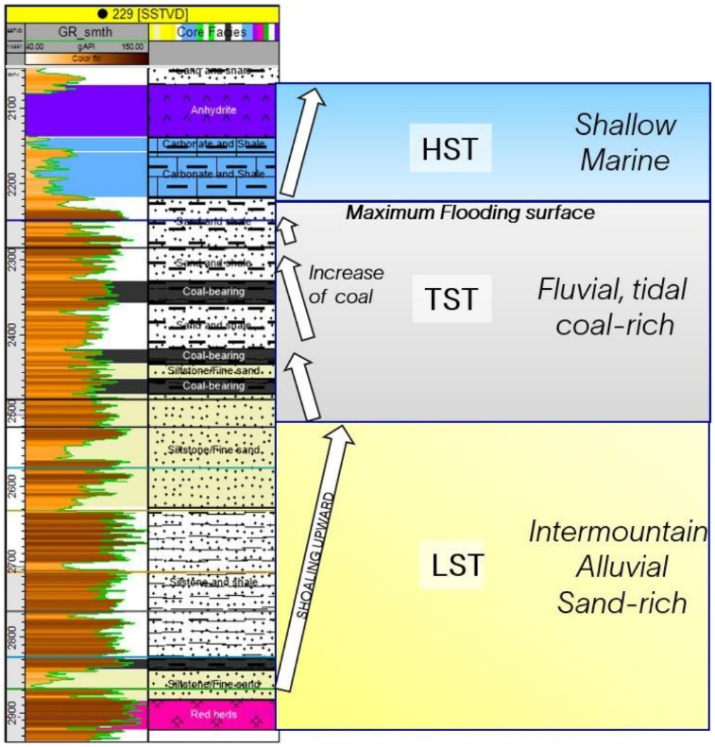

Figure 2—Summary of lithostratigraphic framework of the study area

6

Correlation of stratigraphie markers. The structural framework was constructed based on well markers and seismic horizons, Totally five seismic horizons were identified and picked within the 600m thick Jurassic succession in the study area:
Top of Jurassic–base of shaly, low density and low resistivity Cretaceous rocks Carbonate Top–the top of regional carbonate bed
•
•
Marl–transition from carbonate beds to clean regional shale
•
Key Coal–continuous coal bed, traceable through the entire field
•
Base of Jurassic–base of Lower Jurassic fluvial sandstone bed, unconformably lying on top of Triassic
•
The most challenging part of correlation was related to tracing of the unconformity at the base of Jurassic, especially in the eastern part of the field, where the Early Jurassic sand bed pinches out. Important information was extracted from core and cuttings data, allowing to trace the boundary between loose Permian-Triassic red beds and the Early Jurassic sand bed. Overall, core and cutting descriptions appear in a good agreement with log signature and seismic interpretation. The Permian-Triassic loose sediments show a drastic increase in caliper, decrease In resistivity and density. The loose nature of the Permian- Triassic rocks developed due to subaerial exposure of the rocks during active uplifting stage. The evidence
of unconformity development at the base Jurassic, traced on the seismic and interpreted with consideration
of regional background, core and log data is supported by the analysis of CBIL data. Fig. 4 illustrates position of the unconformity, where the dip angles drastically increase entering Permian-Triassic uplift. The Permian-Triassic sequence is intensively folded and faulted due to active tectonics, associated with compression exerted from the south caused by inversion of the Central Mangyshlak rift system.
Besides the seismically traceable key markers additional well markers, picked based on the sequence stratigraphie concept, related to occurrence of coal-rich layers and maximum flooding surfaces (MFS), were correlated and Incorporated into the structural model. Fig. 3 illustrates the position of the well markers in 10 representative wells of the field.

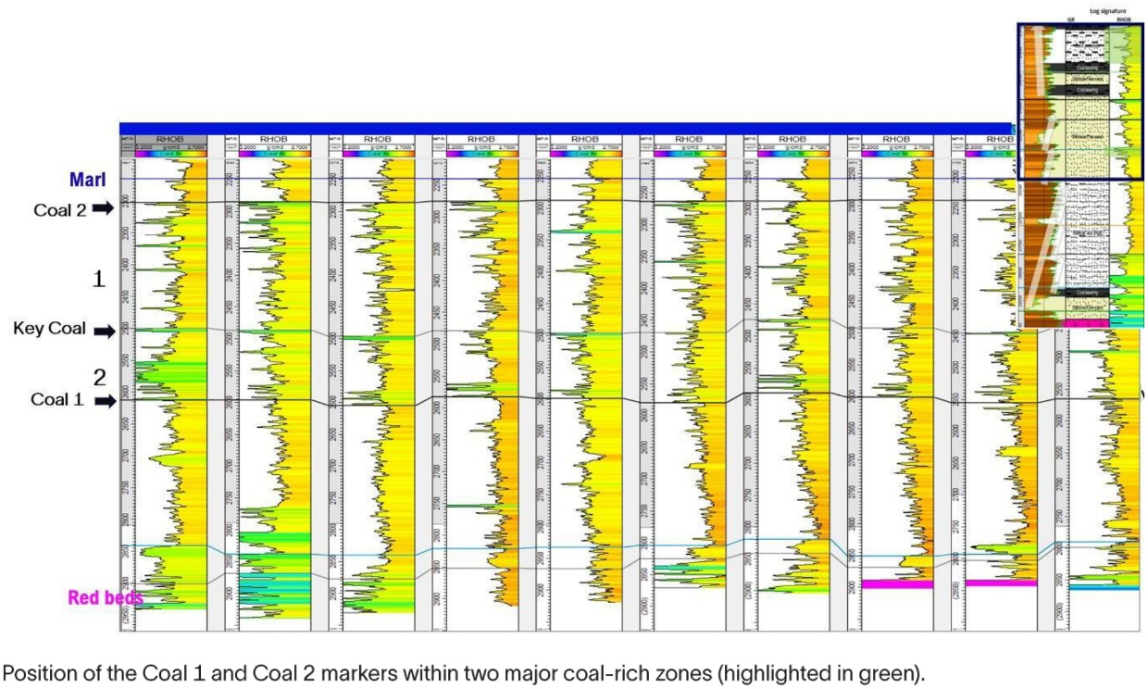

Figure 3—Summary of lithostratigraphic framework of the study area

7

According to the applied concept, the sequence can be subdivided into smaller lithostratigraphic unitis, especially well traceable in the upper part of Middle Jurassic, which is enriched in coal. This part of the sequence consists of a series of repetitive sub-cycles, each starting at the base with sandstone and ending up on top with coal-shale interval, corresponding to flooding event on coastal marshes. An abrupt change from coal/shale to sand marks the parasequence boundary, representing flooding event, implies a move from a relatively higher energy environment with sand deposition to a quieter low energy coal-shale dominant setting, Interpreted parasequences within the upper coal-rich part of Middle Jurassic of the study area are displayed in Fig. 3.
Structural framework. Totally 7 seismically traced and well-tied key horizons and 37 faults were used as input for structural framework generation. The overall structural concept of the area is depicted in the Fig. 4, reflecting the position of Permian-Triassic basement uplift, the development of angular unconformity at the base of Jurassic and generally conformable and gentle distribution of Jurassic horizons. Structurally the area is distinctive in the deeper part of the penetrated sequence, due to development of Permian-Triassic basement uplift. The uplift exerts structural control on the deposition of the overlying Early Jurassic sediments. The Early Jurassic section, largely represented by a braided alluvial sand bed, exhibits pinching out to the south- east toward the Permian-Triassic uplift apex. The 100 m thick sand bed, unconformably overlying Permian- Triassic, gradually decreases in thickness to the southeast, eventually disappearing reaching the apex of the uplift.

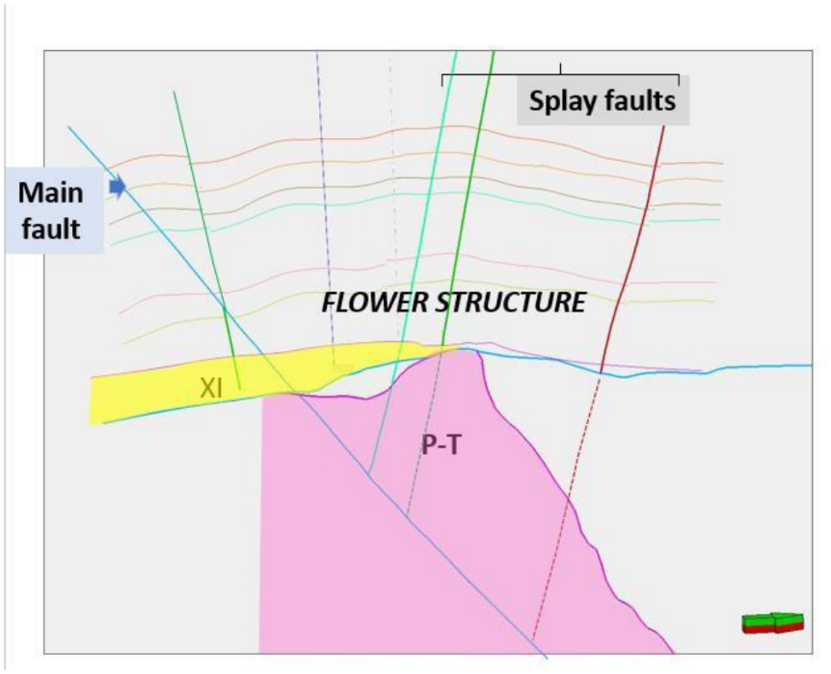

Figure 4—Schematic illustration of Early Jurassic bed distribution in respect to basement uplift.
The fault pattern in the study area is interpreted as strike-slip, aligned parallel to the Central Mangyshlak paleorift system. The master fault runs closer to the southern edge of the field, oriented in the sub-latitudinal direction from the NW to SE. Numerous splay faults associated with the master fault were detected on both flanks of the fault directed to the NE and SW. The displacement of the splay faults is insignificant, not exceeding 15-20 m.
Log signature and core data. Channel system interpretation in the study area was undertaken previously in work by Bashimova et al. (2024). Multiple stacked channel systems were detected within the Early Jurassic and lower part of the Middle Jurassic succession based on analyses of seismic attributes and well log data. Totally 12 individual channel complexes were detected quite extensively all over the entire study area. The

8
channelized complexes were initially detected on the well logs, systematically clustering into individual elongated geobodies akin to channelized systems.
Remarkably, wells located away from the channel system exhibited abrupt sand beds disappearance consistent with transition to floodplain facies. Wells drilled outside of the channel sands exhibit saw-tooth- like log signature, due to thin bed sand-shale alternation, indicating development of flood-plain facies. The sand bell-shaped log signature indicating fining upward together with sedimentological features like cross bedding, scour surfaces, abundant coalified plant remnants, including coal were considered as the signs of fluvial influence. Representative well logs, showing typical fining upward signature are shown in Fig. 5.

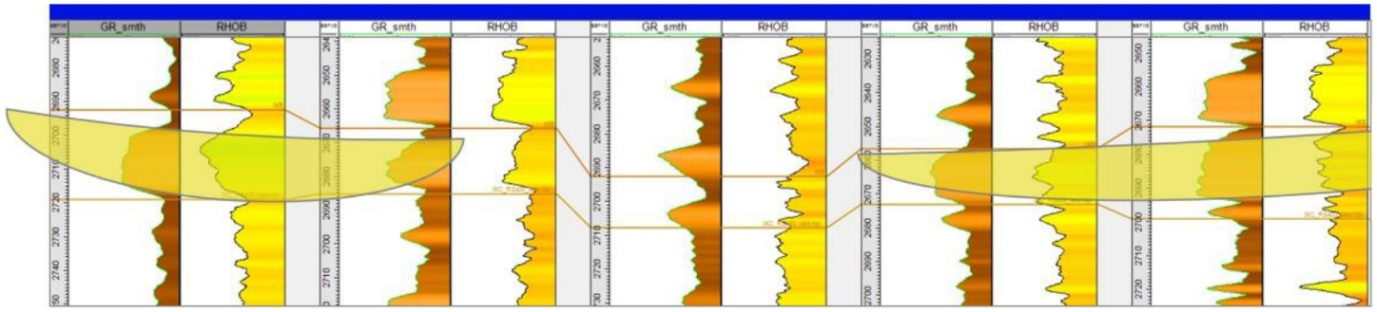

Figure 5—Representative weil section showing log signature of sand bed, interpreted as channelized complex.
The fining upward log signature is associated with general sand bed thinning upward tendency. The Early to Middle Jurassic sequence shows higher enrichment of sand beds in the lower part, gradually thinning upward and replaced by coal-rich shaly intervals. This overall trend is attributable to the general increase of flooding associated with progressive transgression leading to regional establishment of marine conditions during Upper Jurassic. Development of transgressive trend during Middle-Upper Jurassic is consistent with gradual topographical flattening as consequence of tectonic setting prevailing during that time. Gradual decrease of energy due to gentle topography is reflected in the increase of deposition of finer sediments. Enrichment in coal in the upper part of Middle Jurassic can be also linked to inundation as a result of structural gradient decrease and eustatic sea level rise, accompanying transgression. The signs of flattened topography are reflected in the shape of channel belts, detected in the sequence. While Early Jurassic sand bed formed as a braided river, the Middle Jurassic channel systems tend to change upward from straight to meandering. Continuous sea level rise marked the change from continental fluvial to shallow marine transgression leading to formation of carbonate sequences during Upper Jurassic.
Comparison of core and log derived porosity and clay content values of the sediments appeared to be in agreement with interpretation of channel systems. The channel facies show a higher proportion of the petrophysically good reservoir rocks with higher effective porosity (PHIE) and lower Vsh. Sandstones present in the flood plain facies are thin bedded, characterized by lower quality of reservoir properties. Wells drilled outside of the channel sands exhibit saw-tooth-like log signature, due to thin bed sand-shale alternation, indicating development of flood-plain facies, The overall volume of reservoir rocks in the flood plain is overwhelmingly smaller, To obtain quantitative evaluation of the reservoir rocks distributions within the channel and flood plain facies detailed petrophysical rock typing was required.
Seismic signature. The channelized bodies detected by Bashimova et al. (2024) were interpreted as a result of scanning of the horizon slices of the 3D seismic cube flattened to corresponding seismic reflectors. Different seismic attributes were examined, among which the most prominent results were obtained by application of Spectral Decomposition and amplitude-related attributes, such as eXchroma, followed by Envelope, RMS and Sweetness. Interpreted geobodies showed remarkable correlation with log data. Fig. 6 shows example of seismically detected fluvial geobody, compared to the spatial distribution of sand bed at well locations based on well logging data.

9

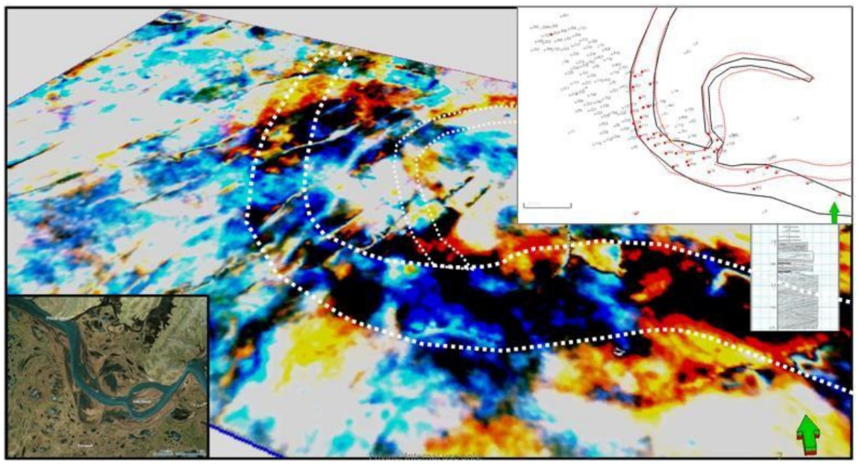

Figure 6—Example of a fluvial system interpreted based on seismic attributes analysis (spectral decomposition). The image on the top right corner shows interpreted channel polygon along with fluvial sand beds within the corresponding subzone (red circles) interpreted on log data.

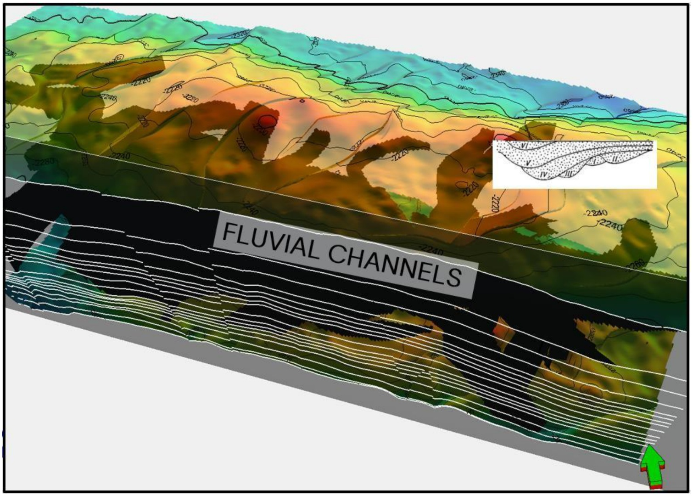

Figure 7—Modeled structural framework of the field with integrated channel system.
The channel belts identified in the Middle Jurassic change upward in shape from straight, branched to meandering. The width of the channel belts varies from 200 to 1500 m, while thickness typically falls in the range of 25-30 m. The largest channel belts occur in the middle part of Middle Jurassic. In the lowermost part

10

of the Middle Jurassic, thickness of channels drops below 25 m, that hindered seismic tracing of the channel belts away from well data. The insignificant thickness of the channel systems was the main obstacle in elucidating channel infill internally. Deteriorated quality of seismic in the zone of interest was another factor limiting the application of seismic in this study. The geobodies representing interpreted channel systems, incorporated into the 3D grid are shown in Fig. 6
Lithofacies classification by petrophysical interpretation
Four different lithotypes were identified within Jurassic pay zones, inferred from the results of petrophysical evaluation, including sand, shale, coal and dense rock. The reservoir rocks are characterized by average porosity of 14.7% and average permeability of 5.6 mD. Large volume of core-derived laboratory measurements coupled with Combinable magnetic resonance (CMR) and X-ray Diffraction (XRD) estimates provided a solid background for application of petrophysical empirical methods. Comparison of core GR measurements to the readings from the well logs ensured accuracy of depth matching. The highest confidence in interpretation was attained for the evaluation of PHIE. The best correlation with core-derived values was attained for acoustic-derived porosity estimates obtained by application of the Raymer-Hunt- Gardner equation, Vsh values were calibrated to RCA and SCAL measurements.
The PHIE of 8.2% was defined as the cut off value for the reservoir rocks. It was not possible to define a PHIE cut-off values to separate for instance clean sandstone from shaly sandstone on the porosity vs. permeability cross-plots due to overlap in porosity values. A wide spread in the combined cross plot for all pay zones appeared as main limitation for reservoir rock classification based on porosity and permeability.
Reservoir rock typing
The optimal number of rocks types codes was defined by using relationship between laboratory measurements of porosity and permeability and pore size obtained from MICP. Quite high correlation coefficient was observable at first in the plot of permeability vs. pore radius. Porosity vs. permeability data, although showing not so high correlation coefficient, appeared meaningfully applicable when combined with MICP-derived pore size measurements with the use of Modified Winland function:

Fig. 8 illustrates results of MICP measurements, showing relationship between pore radius and reservoir rock types, denoted in color: green- good reservoir rock, yellow–moderate, blue- poor. As can be seen in the figure there is quite good spread between rock types in terms of pore radius distribution, allowing to define cut off values for separating good, moderate and poor reservoir rocks. In accordance with obtained results the following cut off values were applied for each of the reservoir rocks type, as shown in the Table 1:

Table 1—Cut off values defined for different reservoir rock types according to modified Winland function.
Rock type Pore size, µm Porosity, % Permeability, m D
Good: >2.4 >12 >10 Moderate 0.8-2.4 8-12 1-10
Poor <8 <8 <1

11

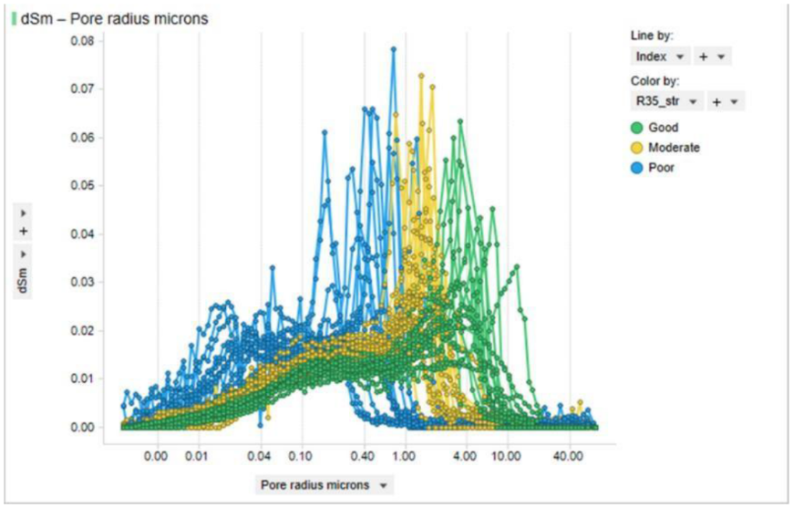

Figure 8—Results of MICP measurements, showing relationship between pore radius and reservoir rock types, denoted in color: green- good reservoir rock, yellow–moderate, blue- poor.

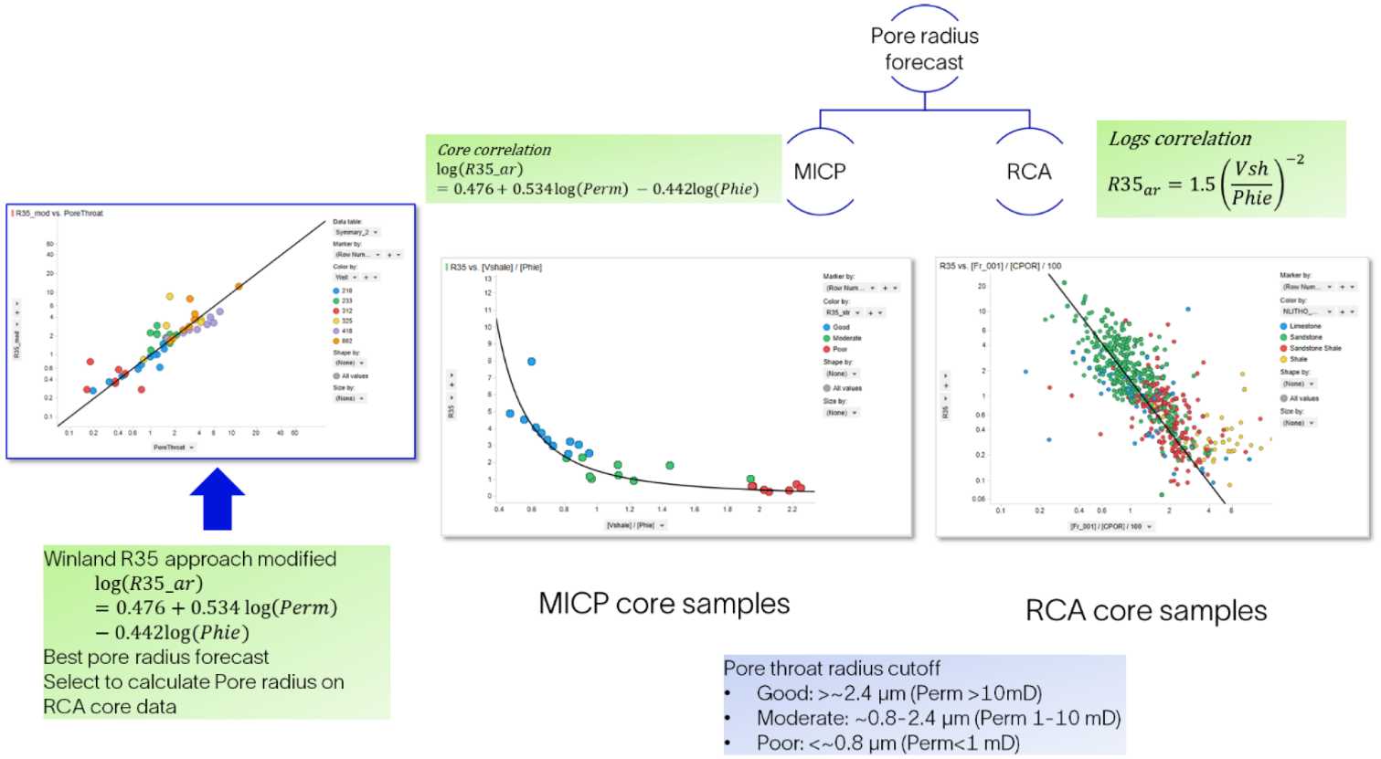

Figure 9—Results of MICP measurements and various core-derived petrophysical equation used for ML training, showing a relationship between pore radius and reservoir rock types.
At the same time the pore radius data were examined against Vsh and PHIE core-derived estimates to find relationship to be applied for well-log-based rock typing. As a result, the following empirical relationship for pore radius prediction was obtained:

This equation together with the modified Winland empirical relationship described above were used to define the reservoir rock types and used as the main input for ML to test and select most effective machine- learning algorithms for well-log based forecasting of reservoir rock types.
Different approaches were applied during ML testing, encompassing classification with and without training. The training dataset covered PHIE, Vsh, density and irreducible water saturation (Swirr,) and

12

reservoir rock type, deduced by application of modified Winland approach (Fig. 8). The resulting trained ML models were applied for predictions on log-derived petrophysical inputs. Among various tested machine learning algorithms Random Forest was found to be the most accurate for well-log-based rock typing with ROC AUC as high as 0.93, implying high effectiveness of ML classification. A reliable match was attained between the ML predicted reservoir rock types and actual core-based classification during testing. 80% RCA core points were used as input for classification, while remaining 20% of samples were used for cross- validation to calculate ML metrics and estimate success of PRT prediction.
Comparison of the well log predicted poro radius values with the experimental results gives a total relative error of 12.51%.
The output of ML classifier in form of discrete logs representing reservoir rock types at well locations was further used as modeling input applied on the whole study area to generate 3D property representing the reservoir rock type distribution. After propagating the reservoir rock types, a verification analysis was fulfilled to ensure the validity of the generated outcome by evaluating the relationship between depositional facies and defined reservoir rock types, The result showed significantly higher enrichment of channel facies in petrophysically good reservoir rocks with higher PHIE above 8% and lower Vsh below 38%, An example
of net pay map, generated for one of the channel belts is illustrated in Fig. 10. As can be seen in the map the net pay values within the channel infill are higher, The overall volume of reservoir rocks in the flood plain part is overwhelmingly smaller, constituting around 10% of the entire rock volume with only 3% represented by good and moderate reservoir rocks, Within the channel facies the proportion of reservoir rocks achieves as high as 58%, that explains the overall better producing performance of the wells. For instance, as illustrated in Fig. 10, good consistency exists between bubbles indicating higher flow rates and the areas of the highest net pay.

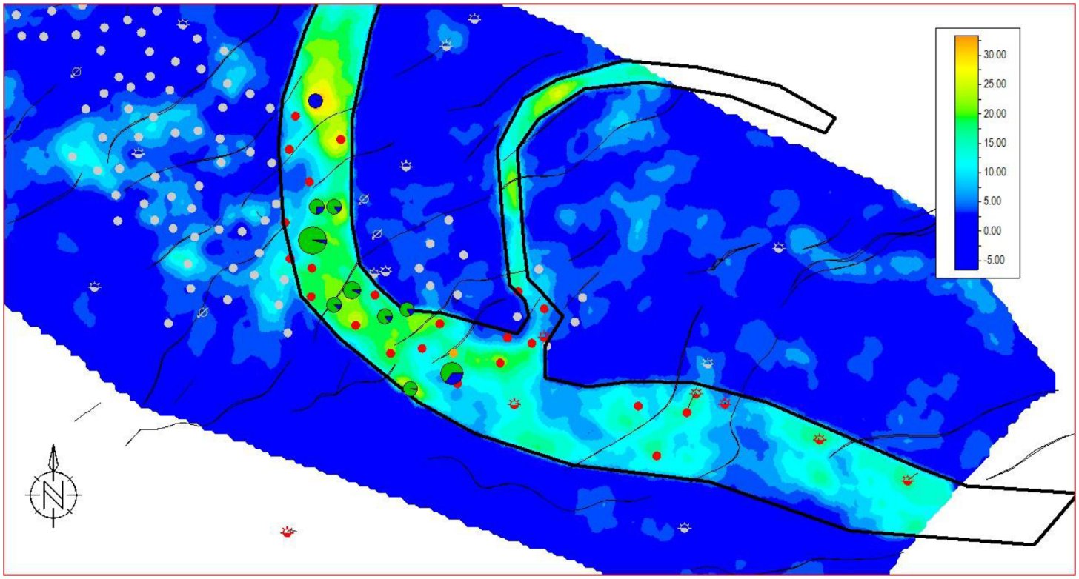

Figure 10—Net pay map extracted from the 3D modeled Itihofacies cube.
Conclusion
In this study an integrated approach was demonstrated to obtain quantitative evaluation of the reservoir rock types within the Jurassic fluvial reservoir of the the North Ustyurt Basin by integrating different dataseis including core, well logs and seismic attributes. The outcome of this study enhances the results of

13

previous seismic facies analyses by integrating into 3D reservoir model to capture details of the reservoir heterogeneity in terms of reservoir quality to locate sweet spots. The reservoir rocks were subdivided into three rock types: good, moderate and poor reservoir rock, with consideration of porosity permeability and pore size cutoffs, defined with the use of laboratory analyses of core samples. The discrete logs depicting reservoir rock types were generated by application of ML supervised training, implementing revealed petrophysical relationships between PHIE, Vsh, density, Swirr, and permeability. Propagated corresponding 3D properties showed good consistency when compared to the observed well performance.
Acknowledgement
Our gratitude is extended to KNOC Geological and Geophysical team, who supported this study. Special thanks to Dilyara Abdulmanova for her contribution in analyses and interpretations.

